Summer Chi.ill Thursday
August 5th Schedule of Events!

2:30 pm - 6:00 pm Registration starts in the Main Lobby
6:00 pm Doors open to Pirate Ship in the Garden Marquis Tent
(Check-in Continues)

All of tonight’s events will be in the Garden Marquis Tent

6:00 pm - 10:00 pm Get your Chicago Style Hot Dogs in the Tent

6:30 Scurvy and the Rotten Scoundrels

And

8:45 Corned Beef and Curry Band

(Music will go on until 11:30 pm)

(they will be trading off all night to keep the party going!)

8:30 pm Heads and Tails game!

Summer Chi.ill Friday
August 6th Schedule of Events!

6:00 am - 10:00 am Private Breakfast For Us (Garden Marquis Tent)

10:00 am Registration opens in the Lower Lobby by pool
10:00 am - 5:00 pm Musician’s Merchandise Sales (Woodfield Room)

10:30 am Tres Amigos Sunny Jim, Kelly McGuire and Mark Mulligan featuring John Patti
(Poolside)

1:00-3:00 pm Ice Cream Truck - Cash only please! (Pool Lawn)

1:20 pm Kim and residents veteran speaks from Cornerstone Services/ Duck Race/ Buffett Buffet (Poolside)

3:40 pm John Patti (Poolside)

6:15 pm - 8:15 pm (Hall just before doors to go out at end of Ballroom Hallway) Pre-Purchase only/ NO CASH

6:30 pm REGGAE NIGHT!
Doors open to the Schaumburg Ballroom!
Raffles and auctions begin!

6:30 pm Shell Game Begins - Buy your shell from our roving sellers and win Big!

7:00 pm - 9:00 pm Photo Booth (Ballroom Hallway)

7:15 pm Ricky Lamb and the Phin Addicts!
8:45 pm Heads and Tails game #2
10:00 pm Reggae Sunsplash All-Star review!

Summer Chi.ill Saturday
August 7th Schedule of Events!

7:00 am - 11:00 am Private breakfast For Us (Garden Marquis Tent)

10:00 am Registration opens in the Lower Lobby By Pool

10:30 am - 5:00 pm Musician’s Merchandise Sales (Woodfield Room)

10:30 am Isabella Stefania (Poolside)

12:00 pm Eric Erdman (Pool Lawn)

12:30 pm - 3:30 pm Hot Dogs…get your hot dogs! (Hot Dog Cart CASH ONLY)
(Pool Lawn area)

1:20 pm Duck Race/ Buffett Buffet (Poolside)

2:10 pm The Detentions (Poolside)

3:40 pm Aubrey Wollet (Poolside)

6:15 pm - 8:15 pm All-you-can-Eat Buffet (Schaumburg Foyer)
Pre-Purchase only - NO CASH

6:30 pm MAGIC OF THE TROPICS (Schaumburg Ballroom)

Raffles and auctions begin!

7:00 pm Welcome Announcements

7:15 pm Floating Collective
8:45 pm Heads and Tails game #3
9:00 pm PB & J
Basket Raffle
9:00 pm Basket Raffle Ends (Schaumburg Foyer)
9:30 pm Basket Pick Up
Silent Auction
9:30 pm Silent Auction ends
10:00 pm Silent Auction Pick Up (Schaumburg Room)

Midnight…you never know what might happen next!

Summer Chi.ill Sunday,
August 8th Schedule of Events!

Salt Water Gospel
10:00 am Doors open Garden Marquis Tent
Breakfast, Bloody Marys and Mimosas will be in the tent!
Must Present Breakfast Ticket
10:30 am until 12:30 pm Brunch is ONLY available to guests who stayed at the hotel Saturday Night.*
10:30 am to 1:30 pm Special Acoustic Set!
2:00 pm See you next year!
* There are no tickets for non-hotel guests.
Drink tickets can not be used for Bloody Marys or Mimosas at this brunch.

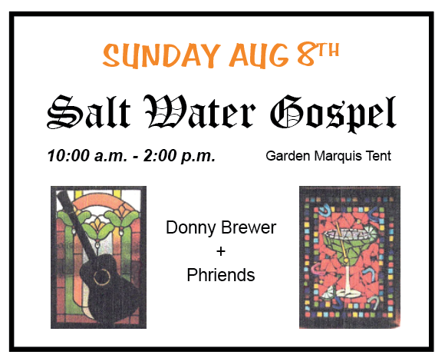

(They will be trading off songs and stories all show and scored by YOU)!

